Project (Daewoo Express)



Submitted to:

Sir Muhammad Asim

Submitted by:

Maida Kosser (221400091) – GL Maheen Saleem (221400063)

Zain Ali (221400084)

Software Requirement Engineering (SE-301-B)

BS Software Engineering (III) GIFT University, Gujranwala

**Class Diagram:**

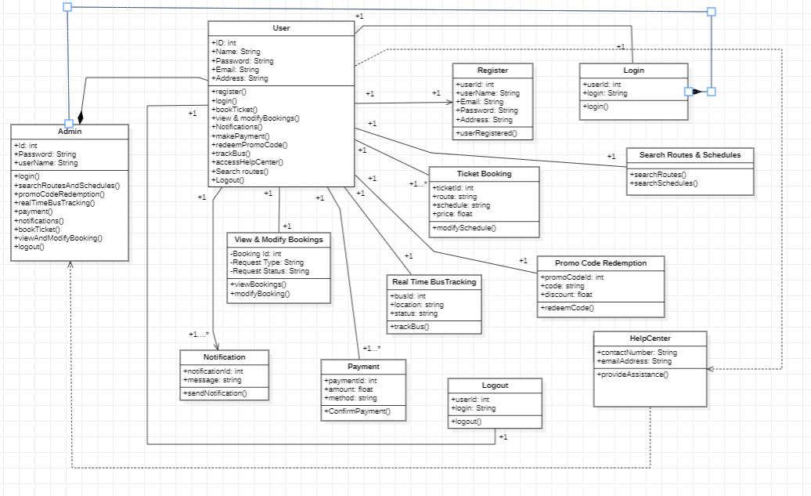

1. **Register:**

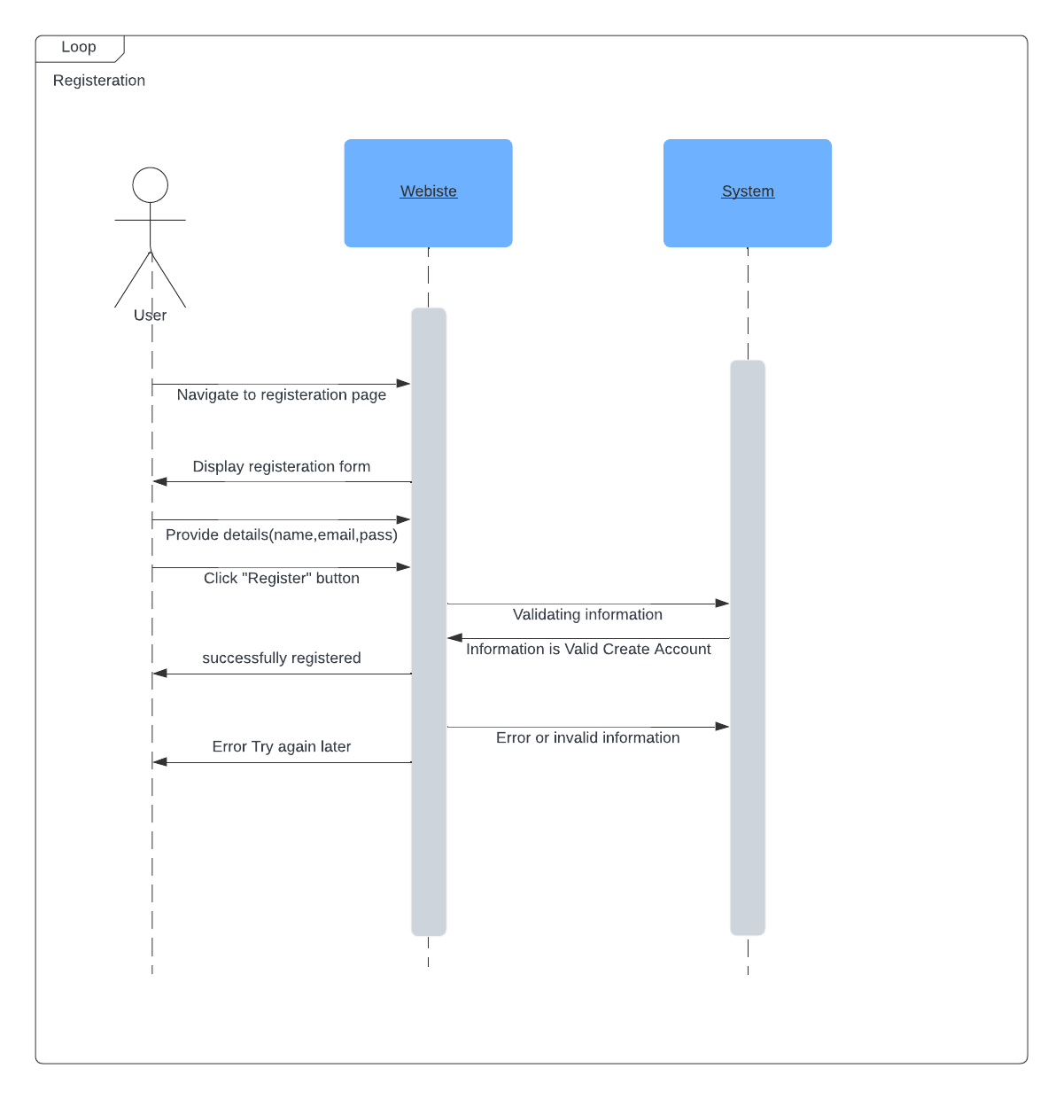

1. **Login:**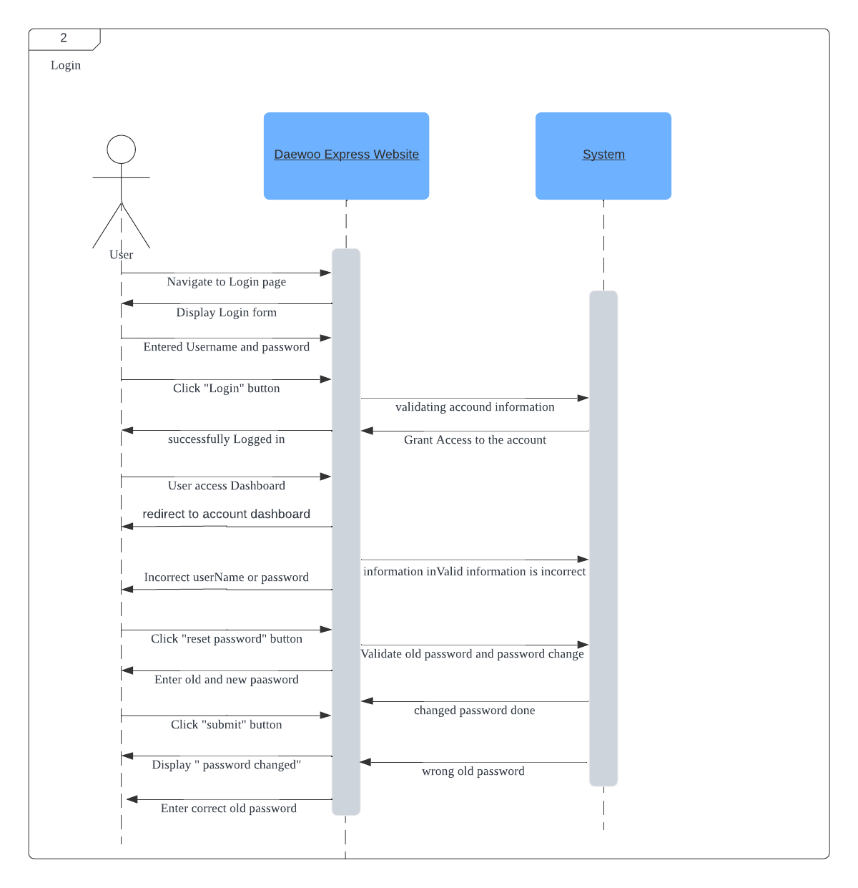
2. **Ticket Booking:**

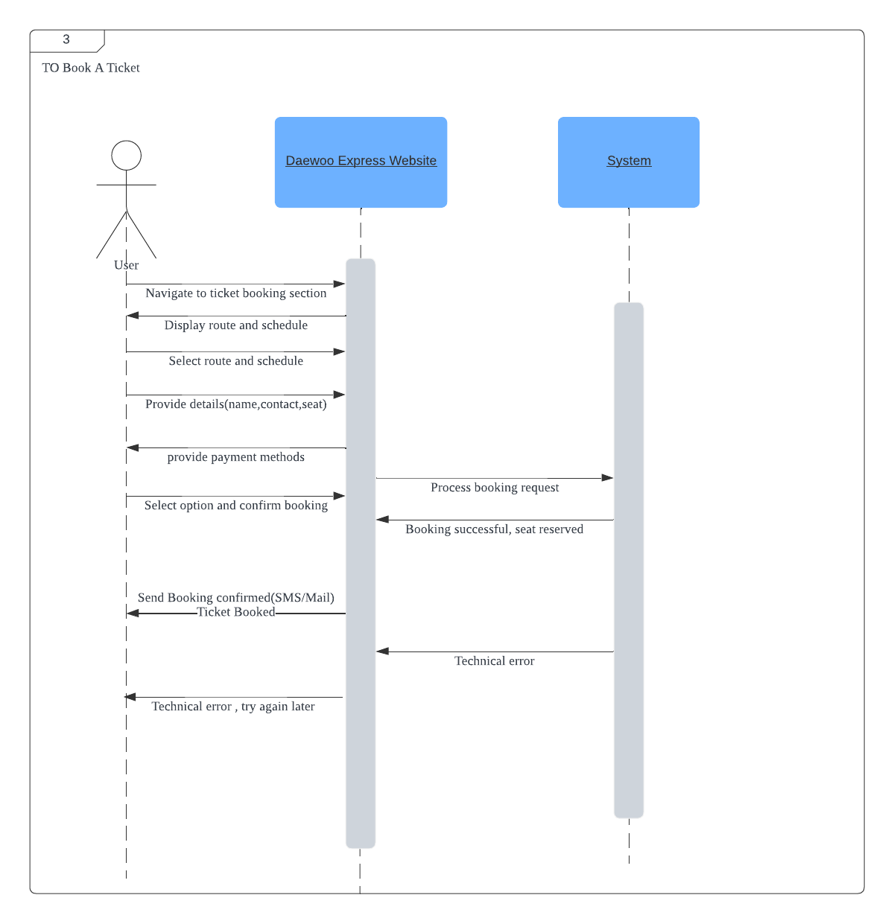

1. **Routes and schedule:**

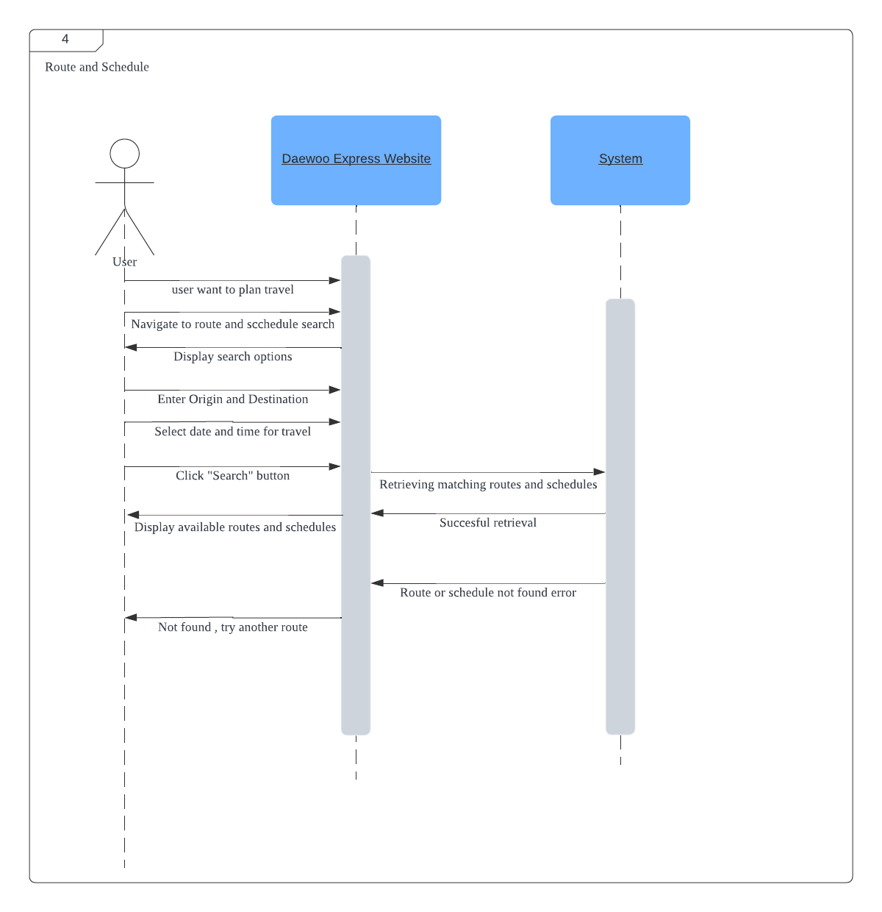

1. **Review and change bookings:**

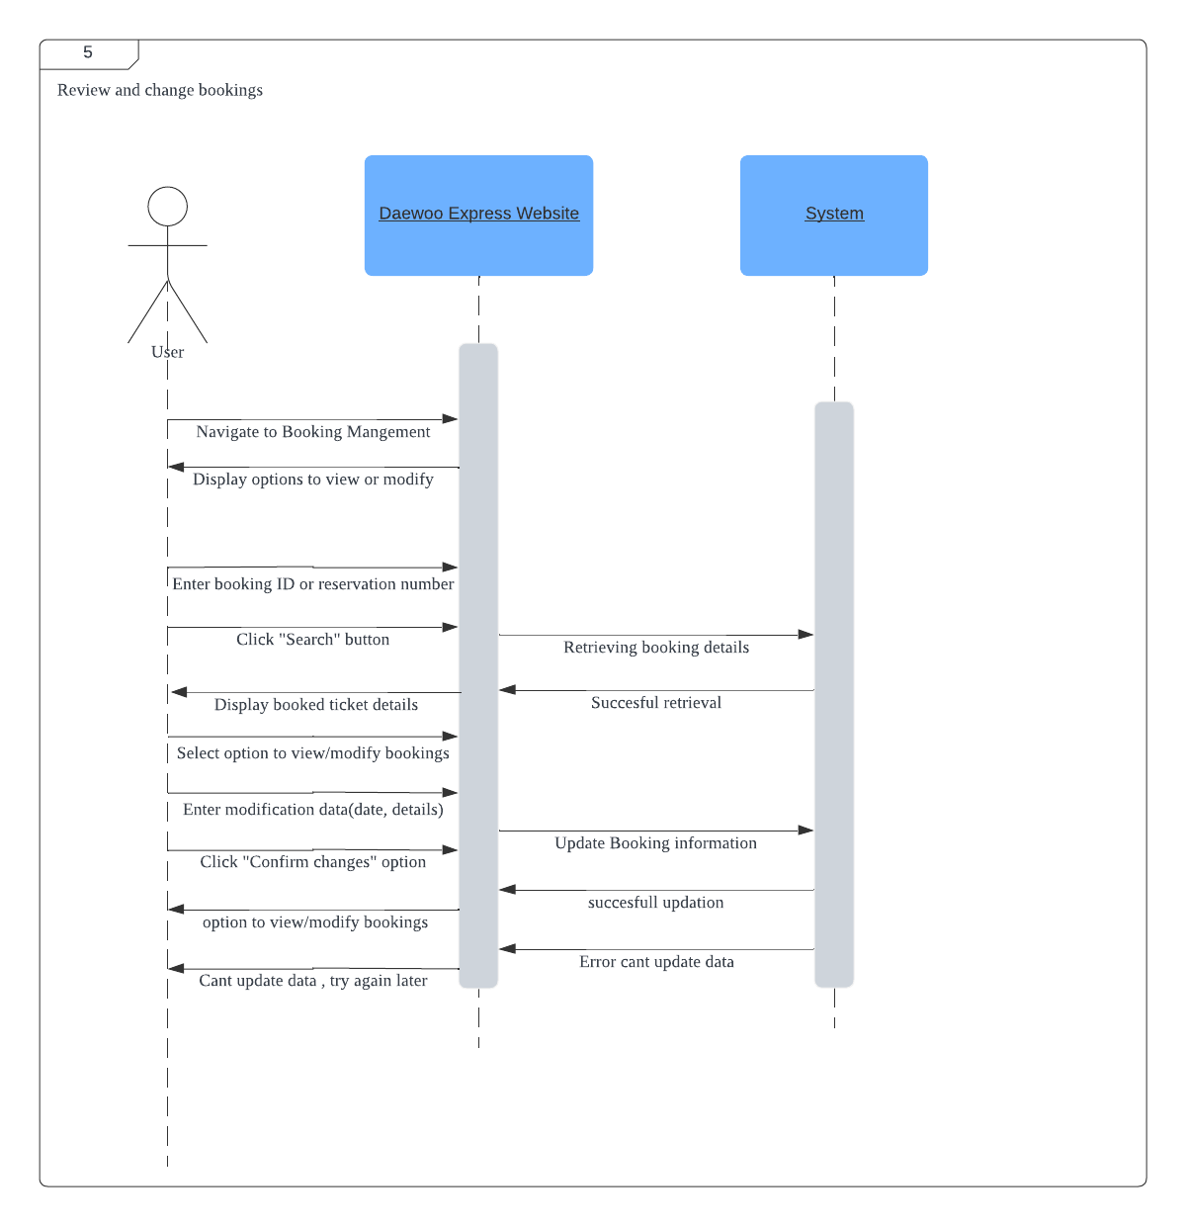

1. **Payment:**

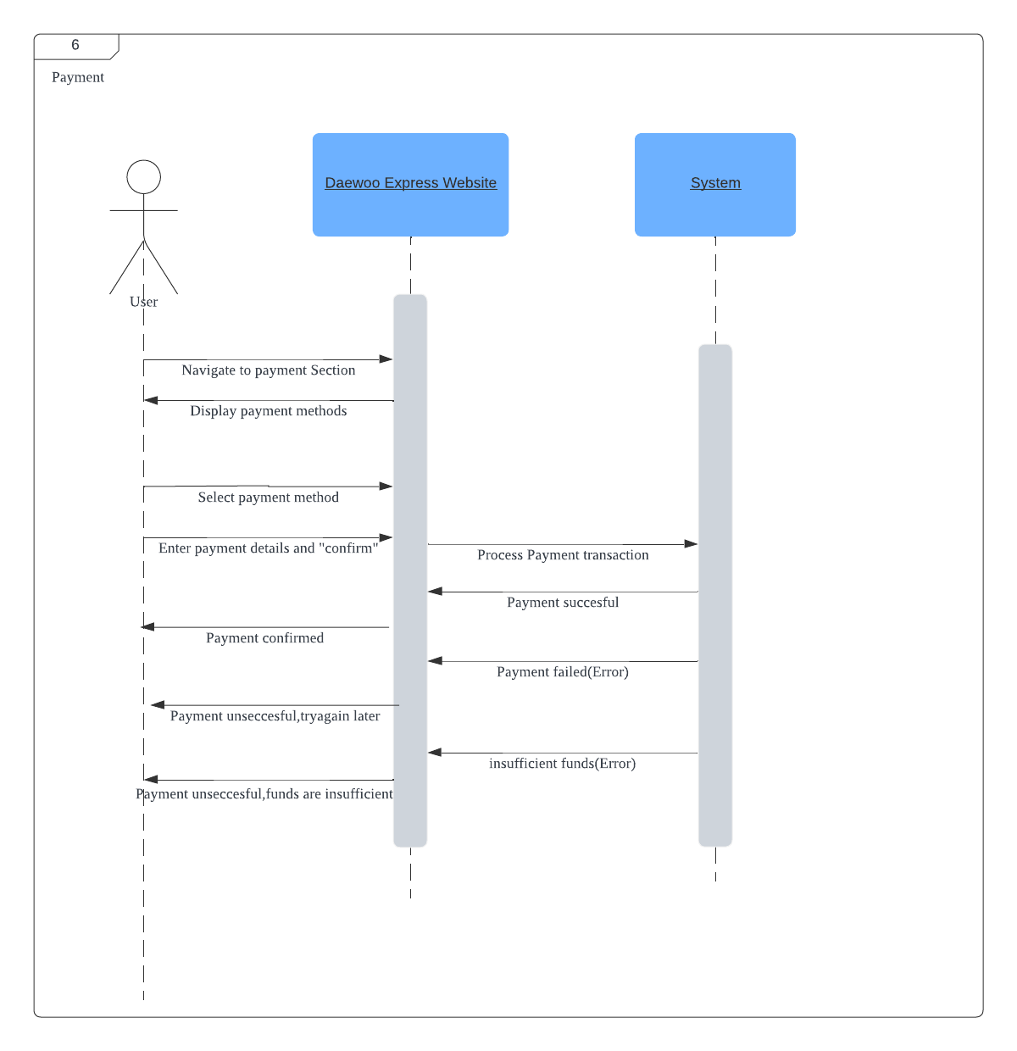

1. **Notifications:**

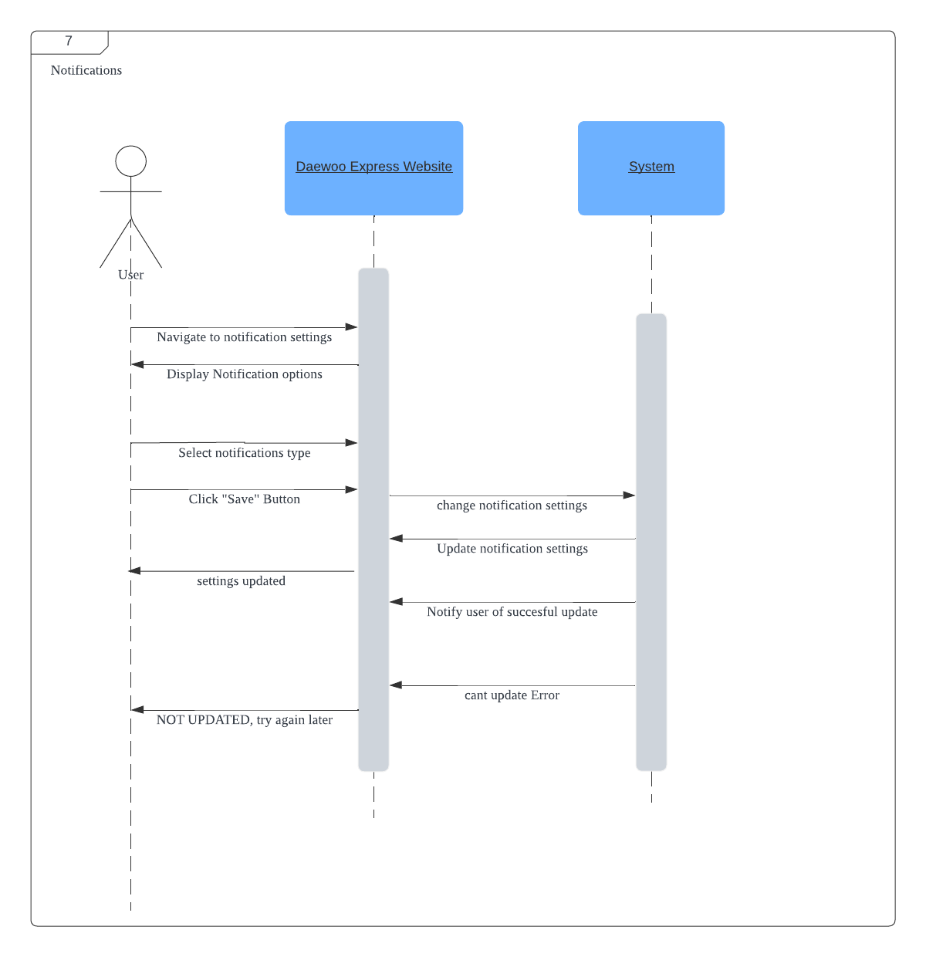

1. **Help Centre:**

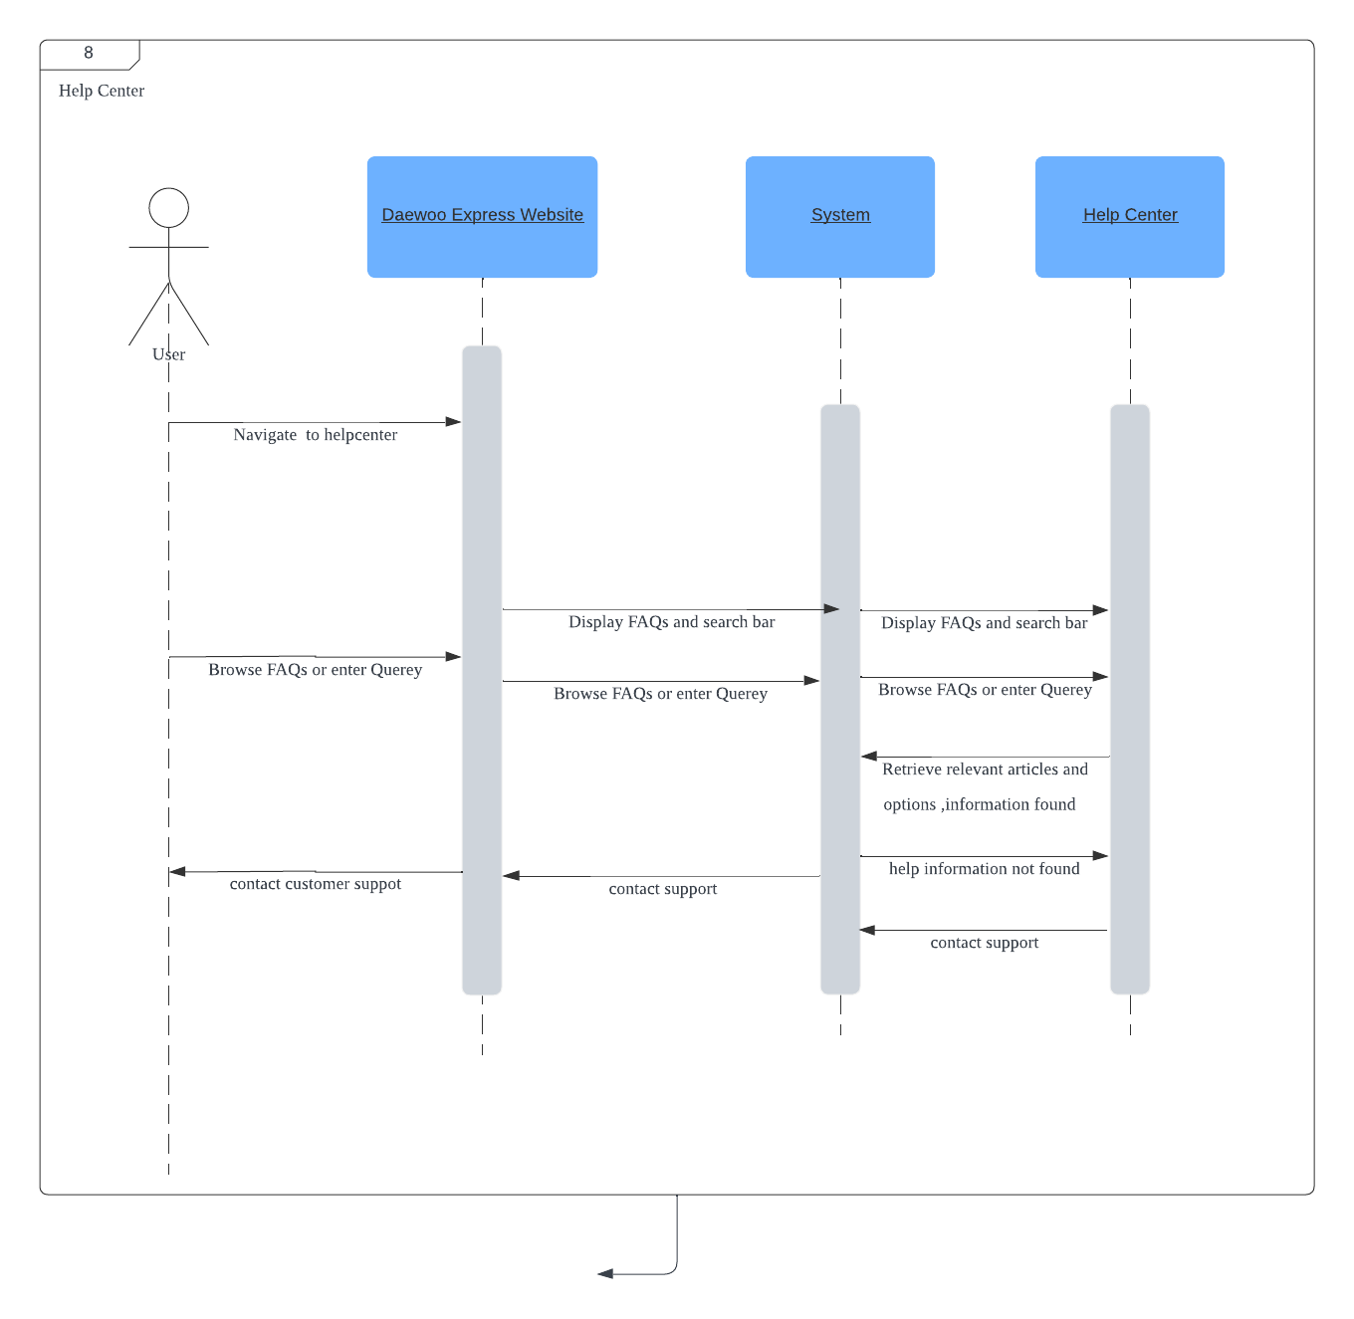

1. **Promo Code:**

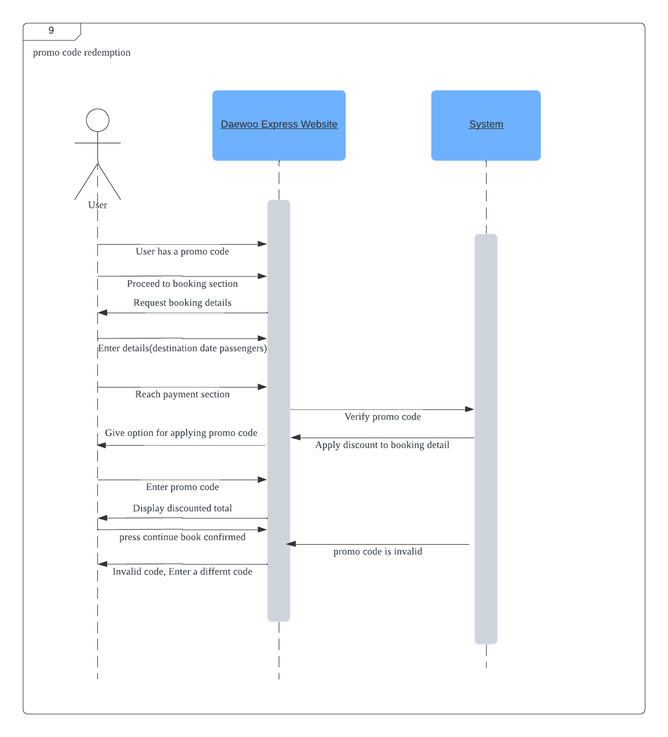

1. **Real-time bus tracking:**

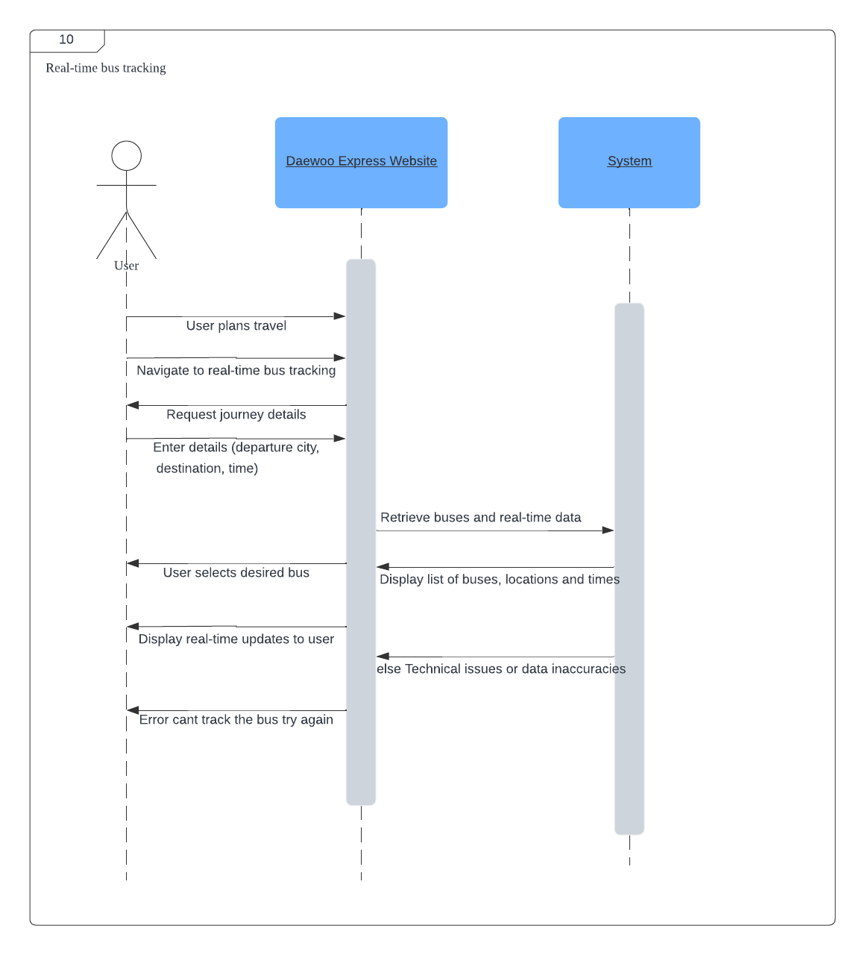

1. **Logout:**

